MINI PROJECT-II

(2020-2021)

**On**

**“Live Search Weather App”**

**MID-TERM REPORT**



**Institute of Engineering & Technology**

**Submitted by:-**

Ashish Agarwal (181500137-C)

Mohan Agrawal (181500385-I)

**Supervised By:-**

Mr. Akash Kumar Choudhary

**Technical Trainer**

**Department of Computer Engineering & Applications**

**Contents**

|  |  |
| --- | --- |
| **1. Introduction** | 1 |
| 1.1 General Introduction to topic | 1 |
| 1.2 Hardware & Software Requirements | 2 |
| **2. Problem definition** | 3 |
| **3. Objective**  **4. Software Design**  **5. Implementation details** | 4  5  6 |
| **6. Progress**  **7. Some Screenshots** | 8  9 |  |
| **8. References** | 13 |
|  |  |

**Introduction**

**1.1 General Introduction to topic**

There are many definitions for weather apps until now but still there is no consensus on one common definition. The weather app information is widely used with different meanings and purposes. In our work, we develop the React Weather app which can provide accurate forecasts to enable users to make informed decisions.

There are many benefits to different people. Since ages, humans want to know about weather conditions in advance and weather apps make it possible to predict weather conditions on the move.

In the project we are going to create live search weather app using React JS. In the project we are using React functional component, React Hooks, React Fetch API, and many more concepts in our live search weather app using React JS. In our live search weather app, the user can know about the weather conditions by entering the city, where the user wants to know about the weather.

Before installing React, we need to install node Js and npm. Also we need to install Visual Studio Code as IDE. After that we install react from the terminal. We can create react app either by using npx or npm.

Using npm we can create react app by using the command given below-:

npm install –g create-react-app

Also, we can check whether the react app is installed or not by using the command given below-:

create-react-app –version

and our react application is successfully installed.

Department Of Computer Engineering & Applications 1

* 1. **Hardware & Software requirements**
* **Hardware requirements:**

1. Processor: i3or above
2. RAM: 4 GB or above
3. Disc space: 20 GB (3 GB for database files + enough GB for shared documents, individual)
4. Network card required

* **Software requirements:**

1. Visual Studio Code as IDE
2. Git Repository
3. Operating System: Windows 7

* **Technologies Used :**

1. HTML
2. CSS
3. JAVASCRIPT
4. React JS

Department Of Computer Engineering & Applications 2

**Problem Definition**

In this project, we are going to make the live search weather app using React JS. We will also use HTML, CSS, JavaScript in our project. We will use React Functional Component, React Hooks, React Fetch API and many more concepts in our live search weather app. In our live search weather app, the user can know about the weather conditions by entering the city, where the user wants to know about the weather.

The aim of this project is to provide accurate forecasts to enable users to make informed decisions.

Since ages, humans want to know about weather conditions in advance and weather apps make it possible to predict weather conditions on the move.

Department Of Computer Engineering & Applications 3

**Objective**

The problem discussed above is only reason to developing this kind of application. **“Live Search Weather App”** gives better user experience for knowing the weather conditions across different cities.

1. Easy to use and portable.
2. The user can easily enter the city name if it exists, then it shows the current temperature in that city in degree Celsius and also if it does not exists, then it shows No Data Found.
3. The user would be able to get the minimum and maximum temperature in the city.

Department Of Computer Engineering & Applications 4

**Software Design**

1. **Activity Diagram:**

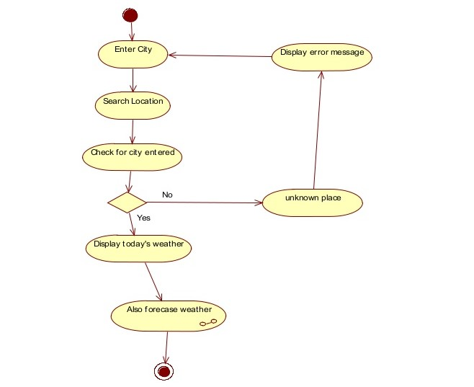

Department Of Computer Engineering & Applications 5

**Implementation Details**

**Step 1-:** Firstly, we install our react application by using npx tool or npm tool.

**Step 2-:** After installing react application, we run the command given below -:

npm start ,

which starts the development server and our react-scripts start.

**Step 3-:** When we create react app, it automatically gets created lots of files and folders.

The React Folder structure looks like-:

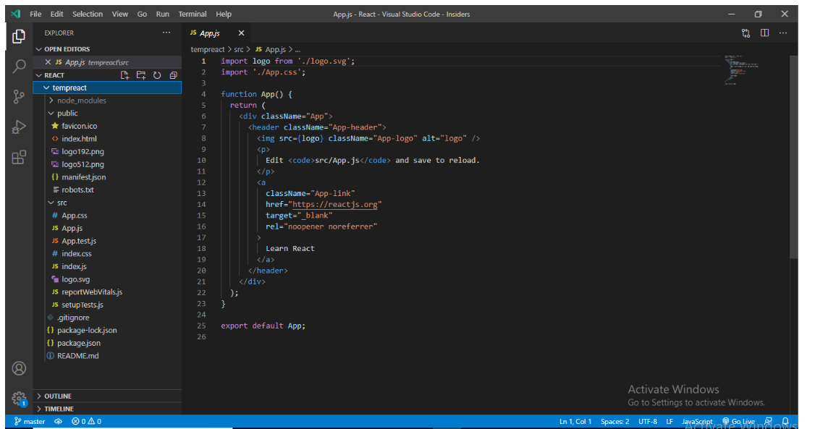

Department Of Computer Engineering & Applications 6

We Create a React app named “tempreact”.

Basically, the react folder structure contains three folders-:

1.node_modules

2.public

3.src

Package.json is a standard file found in every project. It contains the information like the name of project, versions, dependencies etc.

At the time of working with React application, for the project to build, these files must exist with exact filenames.

1. **public/index.html** is the page template.
2. **src/index.js** is the JavaScript entry point.

**Step 4-:** Inside the src folder, we have created the folder named “components” and inside this folder we have created the file named “Tempapp.js”. Inside the Tempapp.js file we create a functional component called Tempapp and inside that we created two classes named “box” and “inputData” and we import the css file inside the Tempapp.js file.

Department Of Computer Engineering & Applications 7

**Progress**

At that time we have created react app named “tempreact” and created the file named

“Tempapp.js” where we import the CSS file which stores the styling of our application.

In our project index.html is the single html page .index.js is the JavaScript entry point.

Some CSS part is remaining and some implementation of react is remaining.

Department Of Computer Engineering & Applications 8

**Screenshots**

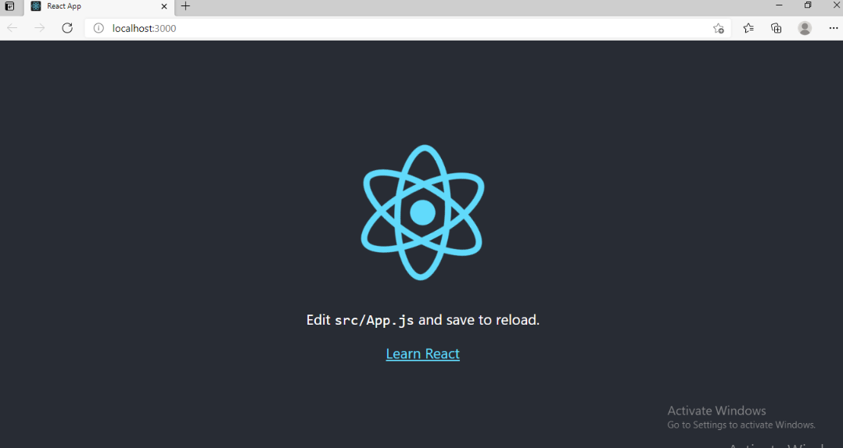

**It shows that our react application is successfully installed.**

Department Of Computer Engineering & Applications 9

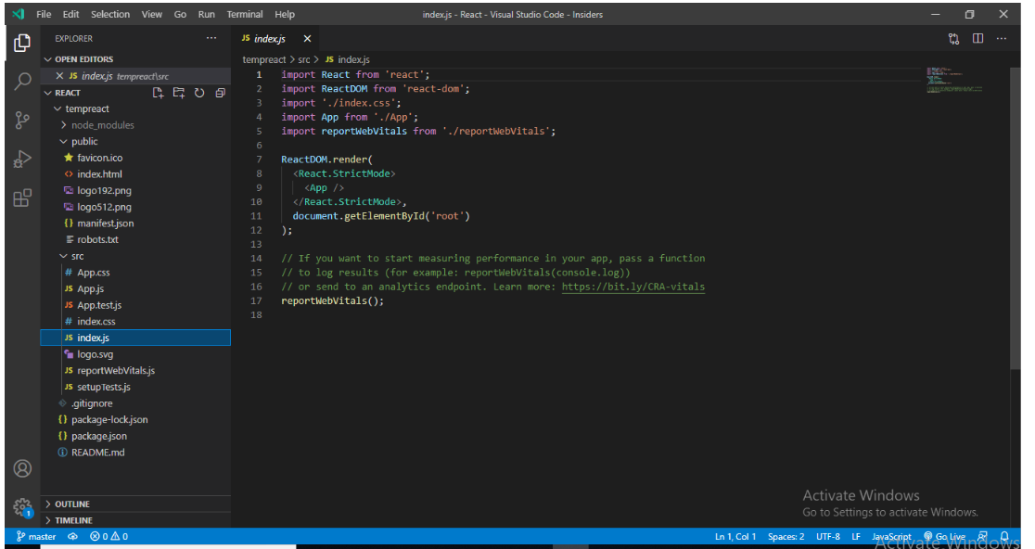

**In index.js file we import the app component and app component is called in index.js file.**

Department Of Computer Engineering & Applications 10

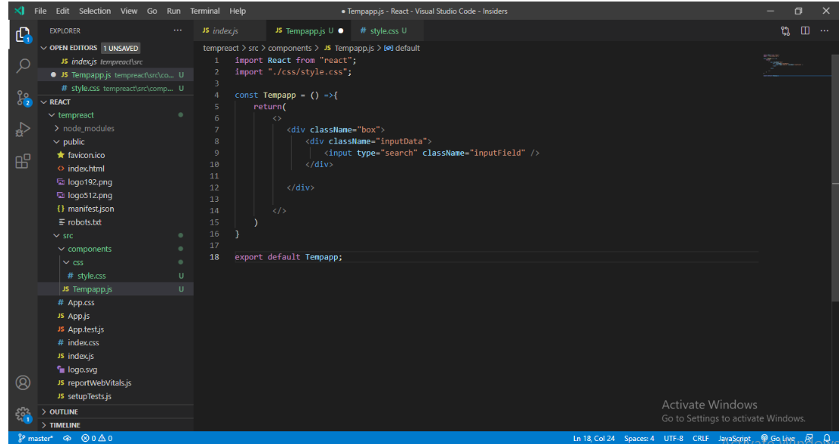

**In the Tempapp.js file we import the CSS file which stores the styling.**

Department Of Computer Engineering & Applications 11

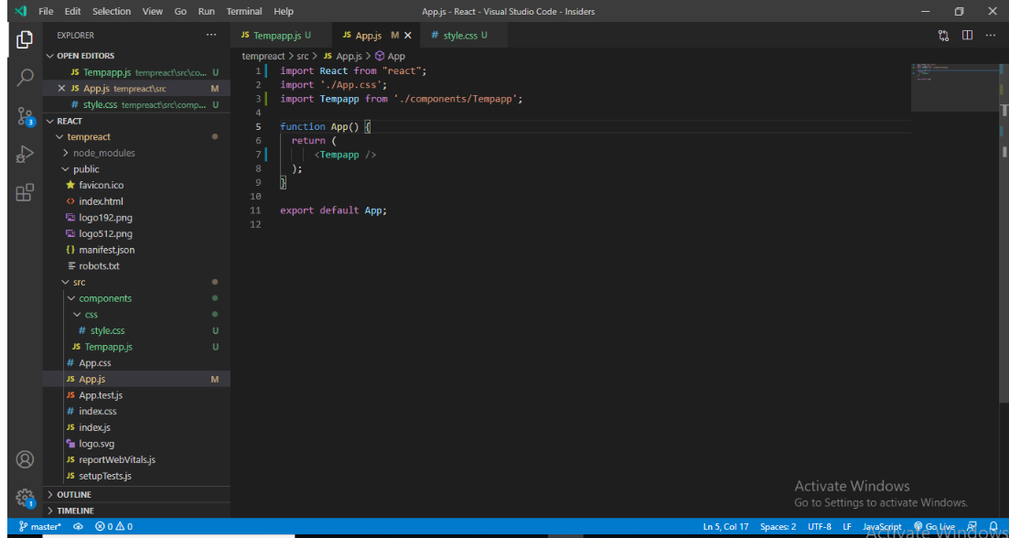

**In the app.js file we import the Tempapp component and call this component in the app.js file.**

Department Of Computer Engineering & Applications 12

**References**

<https://www.beta-labs.in/>

https://rapidapi.com/blog/weather-app-react/

Department Of Computer Engineering & Applications 13